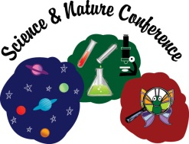
Science & Nature Conference
May 7, 2024
Student/Adult Survey

- Select One
Student Adult

- What grade are you in? (Select One)
K 1 2 3 4 5 6 7 8

- Rate the Keynote Presentation
Excellent Good Average Fair
- What did you learn during the Keynote Presentation?

- Did you explore and learn something new at the conference?
Yes, for sure Kind of Not so much

- List the three sessions you took (by letter or title):

- What was your favorite session and what was fun about it?

- What did you learn about science or technology in your sessions?

- Would you attend the Science & Nature Conference again?
Yes No Maybe

- Adult: How has this experience influenced your child/student(s)?

- Overall Conference Content?
Excellent Good Average Fair Poor

- Overall Conference Organization?
Excellent Good Average Fair Poor

- Additional comments about the conference:

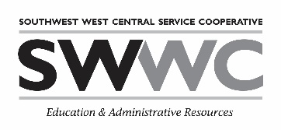
- Suggestions for future topics, speakers, etc.

